Argus
Flash Flood Alert System

Project Proposal
V 1.0

By
1 | Rabia Irshad | NUM-BSCS-2025-46
2 | Shumaila Nawaz | NUM-BSCS-2025-53
3 | Syed Danial Hassan | NUM-BSCS-2025-56
4 | Syed Saeed Raza Shah | NUM-BSCS-2025-57


Department of Computer Sciences
Namal University
Mianwali, Pakistan
Submission Date : 9th October, 2026
REVISION HISTORY
Date | Version | Description | Approved by
09-10-26 | V 1.0 | Initial Proposal Submission | Ms. Shehr Bano
.

TABLE OF CONTENTS
1. INTRODUCTION: 5
2. PROBLEM STATEMENT: 5
3. PROJECT OBJECTIVES: 5
4. PROJECT SCOPE: 5
5. STAKEHOLDER IDENTIFICATION: 6
6. SOFTWARE DEVELOPMENT METHODOLOGY: 7
7. TOOLS AND TECHNOLOGIES: 8
REFERENCES 10

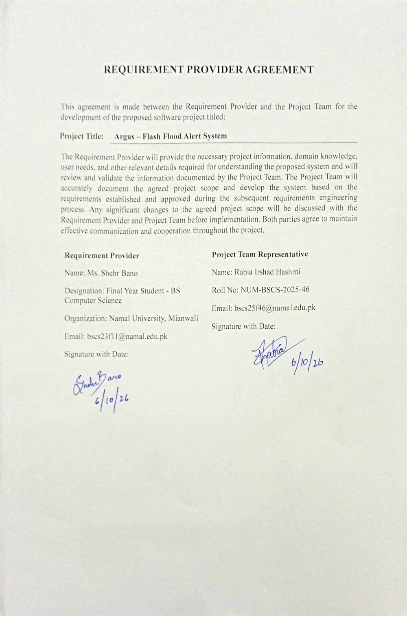

INTRODUCTION
ARGUS is an application used in disaster risk management technology. Flash floods are common in mountain areas. With the presence of steep slopes and short but heavy rains, water drains into streams at a faster rate. This quickness of the flow makes it challenging to prepare or respond even when a warning is issued or when the flooding begins. In August 2025, 400 tourists were rescued in Bagh district, Azad Kashmir, after being caught by a flood in a nala, which is a seasonal stream channel. [1]
The nala is an example of an ephemeral stream. The flow of such streams comes after rain and is rarely monitored. According to hydrology studies, flow monitoring in intermittent and ephemeral streams is rarely conducted by public agencies; temporary streams are normally not included in stream monitoring systems; and flash floods tend to occur in ungauged catchments. This means that warnings related to rain are not connected to the streams that can become risky. ARGUS provides a solution in Bagh district by mapping known flood-prone ephemeral channels and comparing them with the forecasted rain to flag those channels whose forecasted rain surpasses the set thresholds. These are presented on a map to provide disaster risk information to help communities and relevant authorities identify potentially hazardous channels before or during heavy rainfall.

PROBLEM STATEMENT
When a flood occurs, it carves or widens a channel that becomes a high-risk path for future water flow, yet such channels are rarely monitored like formal river systems. As a result, although rain predictions exist, the people living around these channels or traveling along the mountain roads do not get any warning relevant to their situation, since these floods occur immediately after rain. This disconnect between available weather data and localized hazard knowledge leaves at-risk communities uninformed, even though the information needed to warn them already exists separately.

PROJECT OBJECTIVES
- To create an interactive map of the Bagh district with pre-defined flood prone channels displayed as hazard data in GeoJSON format.
- To incorporate real time forecasted rainfall data for the Bagh district by connecting to a weather API and refreshing forecasted values at regular intervals during the lifetime of the system.
- To create a threshold-based warning system that triggers when the forecasted rainfall near any flood prone channel crosses a certain danger threshold value.

- PROJECT SCOPE

  - Inside Scope:
- Interactive mapping interface for a single selected mountainous area (Bagh district, Azad Kashmir) showing the terrain and existing hazard points
- Pre-identified and researched channels that are vulnerable to floods (ephemeral stream tracks) in this area as GeoJSON hazard layer in the map
- Live rainfall forecast integration from a weather API for the selected mountainous area
- Threshold based alerting of tracks which are high hazard if forecasted rainfall at that track is above certain danger threshold
- Basic visualization of alerts in the map
- Back end system for storing the hazard tracks, fetching and refreshing weather forecast and executing the alert mechanism
- Documentation of data sources and methodology behind flood-prone channels identification for the selected region

  - Outside Scope:
- Automatic discovery of new channels for flooding through satellite imagery, remote sensing or computer vision technologies: the project uses a static dataset researched previously, not live geological analysis
- Application beyond the single chosen region: the project is scoped to a single region/district only
- Real-time integration with sensors measuring water level: the project works based on forecasts, not actual sensors/IoT devices at location
- Development of mobile applications: the project is scoped to a web-based map application
- Integrations with national systems for managing disasters (such as NDMA/PDMA systems): the project is a standalone concept, not an officially released government application
- SMS/push notification system: notifications are presented via interface of the application; email/SMS notifications can be added in future versions

- STAKEHOLDER IDENTIFICATION

Table 1: Stakeholders and Their Roles in the Proposed System
Stakeholder | Role | Interaction with System
Local Disaster Management Authority | Primary end user | Monitors the system's map and alert dashboard during monsoon season to track forecasted rainfall against known flood-prone channels, using it to inform decisions on issuing local warnings or evacuation advisories
Residents of flood-prone areas (Bagh Disctrict) | Indirect beneficiary | Do not interact with the system directly; receive benefit through warnings/advisories issued by the Disaster Management Authority based on system alerts
Traverlers/Tourists | Indirect beneficiary | Benefit indirectly if local authorities use system alerts to issue route advisories during high-risk periods
Requirement Provider | Project client and advisor | Defines requirements, validates that the system's design and alert logic align with real disaster-management needs, provides feedback throughout development
Development Team | System developers | Design, build, test, and maintain the system — including hazard-track data collection, backend alert logic, and the map interface
Course Instructor | Academic Supervisor | Assesses the project proposal, implementation, and team's understanding against course requirements
- SOFTWARE DEVELOPMENT METHODOLOGY
Methodology: Agile (iterative, Scrum-inspired)
  - Why It Suits Argus
- Requirements are yet to be developed alongside the RP. Data sources for channels and floods and also triggers for alerts are not clear yet, and a flexible approach will handle this problem better than a rigid process.
- The system itself naturally divides into increments that can be developed and demonstrated separately: map, hazard layer, integration of weather conditions, logic of alerts, interface for authorities.
- The module course requires regular meetings with the RP monthly, which can take place during iteration reviews and thus affect the next iteration.
- The team learns while developing. Small iterations help make changes in the project plan based on the results achieved and realistic capabilities of the team.
- Why not Waterfall: it requires complete and stable requirements before starting with designing, and it postpones testing till the end of the year. It is too risky for inexperienced team.
  - How It Guides Phases
Table 2: Phases according to agile methodology
Phase | Activities done during this phase in ARGUS
Planning | Scope, objectives definition; backlog creation; role allocation in team; repository creation
Analysis | Requirement gathering from the RP; research on flood-prone channels in Bagh; selection of weather data source; risk threshold approach definition
Design | System design; database design; map and alert view mockup
Implementation | Development iteratively, one feature set at a time
Testing | Incremental testing upon completion of each increment, also integrated testing with sample rainfall situations towards the end
Delivery | Demonstrations after each major increment; final integrated system and presentation at the end of the year
  - Team Organization
The team comprises of four people. All are newbies, and thus ownership will be decided after the exploration phase. There are four modules, and each one is taken by one member, namely: [development of the map, user interface, data in flood channels, and documentation and testing]. During the first few weeks, each one goes through a beginner's guide in one module and gives feedback, which then decides on the ownership by interest and what is possible. Ownership of each module is done individually, while difficult tasks are carried out in pairs. Assessment is done individually, hence all should understand the whole system.
  - Monitoring Development Activities
The team meets weekly to discuss what each individual has accomplished and what problems he or she faces. The tasks are listed on the board for each member in one of the three states: to do, in progress, and completed. All codes are kept in the GitHub account of the team. Progress is evaluated with the help of the RP once a month, as well as in the minutes.
  - Incorporating Feedbacks
In every RP meeting that happens once a month, the group will present their achievements. The input of the RP is documented in the minutes and included in the tasks, and they work on them in the following month.
  - Managing Changes
In case a change is recommended by the RP or one of the team members, the team deliberates on the effort involved and its compatibility with the time frame and scope as defined in the plan. It is decided then by the RP and the team as to whether it should be included, postponed, or left out.
  - Gantt Chart
Figure 1: Project Timeline
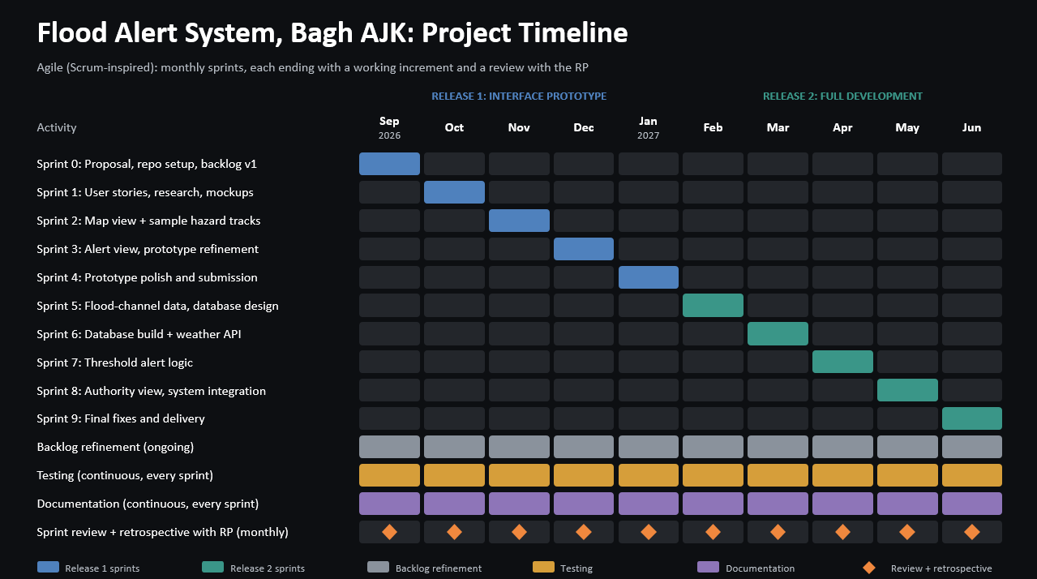
- TOOLS AND TECHNOLOGIES
Table 3: Proposed Tools and Technologies
# | Tools and Technology | Purpose
1. | HTML, CSS, JavaScript | Build the web interface that users see and interact with
2. | Leaflet.js | Display the interactive map and draw the flood channels on top of it [3]
3. | OpenStreetMap | Supply the base map imagery under the channels [4]
4. | GeoJSON | Store the coordinates of each flood channel in a format the map can read [8]
5. | geojson.io / QGIS | Trace flood channels on a map and export them as GeoJSON files
6. | Open-Meteo API | Provide rainfall forecast data for the Bagh region [7]
7. | Python with Flask | Run the backend that fetches forecasts, checks them against the risk threshold and sends the results to the map
8. | MySQL | Store the flood-channel data, fetched forecasts and alert status [5]
9. | Figma | Design mockups of the interface before it is built
10. | Git and GitHub | Version control, shared repository and task tracking for the team
11. | VS Code | Write and edit the code [6]

REFERENCES
- “10 perish as flood fury ravages AJK, G-B,” The Express Tribune. [Online]. Available: https://tribune.com.pk/story/2561368/10-perish-as-flood-fury-ravages-ajk-g-b. [Accessed: Oct. 3, 2026].
- Claude (Anthropic), “Shared conversation,” accessed: Sep. 23, 2026. [Online]. Available: https://claude.ai/share/364e756d-da53-4a83-8b93-436da6424138.
- Leaflet, “Documentation.” [Online]. Available: https://leafletjs.com/reference.html. [Accessed: Oct. 9, 2026].
- OpenStreetMap contributors, “OpenStreetMap Wiki.” [Online]. Available: https://wiki.openstreetmap.org/. [Accessed: Oct. 9, 2026].
- Oracle, “MySQL Documentation.” [Online]. Available: https://dev.mysql.com/doc/. [Accessed: Oct. 9, 2026].
- Microsoft, “Visual Studio Code Documentation.” [Online]. Available: https://code.visualstudio.com/docs. [Accessed: Oct. 9, 2026].
- Open-Meteo, “Terms and Conditions.” [Online]. Available: https://open-meteo.com/en/terms. [Accessed: Oct. 9, 2026].
- [1] GeoJSON, “GeoJSON.” [Online]. Available: https://geojson.org/. [Accessed: Oct. 9, 2026].

